**Moss species distribution patterns and their dependency to different substrates and forest structures**

A modified nested plot design approach in a typical temperate central European forest near Marburg (Germany)

Andreas SchönbergB.Sc.1 , Alexander Schupp B.A., B.Sc.1,2 & Jan Schwalb B.Sc.1

1Master student at the department of Geography, Philipps University of Marburg, Germany

2Master student at the department of Archaeology, Philipps University of Marburg, Germany

**________________________________________________________**

**Abstract**

The importance of bryophytes and their role in ecosystems has been underestimated for a long time in environmental research. In this study we focused on the detection of moss distribution patterns in different habitats and substrates in a central European temperate forest. We use a customised nested plot design for the field survey to improve the accuracy and reliability of moss occurrence and richness as well as to collect data from different substrates within a vegetation plot. Further we investigate the vertical distribution of epiphytic moss species estimating a dependency on the respective tree species. For the data analysis we use several statistical approaches like multivariate statistics and correlation tests. Our results suggest that the distribution of moss compositions depends on the substrate (soil, deadwood and epiphytic) while the maximum growth height of epiphytic mosses depends on the tree species.

**Keywords:** Bryophytes, Nested plot design, Substrate dependency, Distribution patterns, Multivariate statistics, Cluster analysis and ordination, Vertical epiphytic moss distribution

**________________________________________________________**

**1. INTRODUCTION**

Bryophytes are the second biggest species group within the plant kingdom behind the much larger angiosperms (Crosby et al. 1999, Frahm & Frey 1992). There are approximately 25,000 species taxonomically divided into hornworths (*Anthocerotopsida*), two classes of the liverworts (*Marchantiopsida, Jungermanniopsida*) and the mosses (*Bryopsida*) (Zechmeister et al. 2003). Unlike many other plants bryophytes can reproduce both sexually and vegetative (Frey & Kürschner 2011, Mishler 1985). Current research suggests that mosses play an important role as an omnipresent component in plant communities worldwide and strongly influence the water, nutrient and carbon cycle of their habitat (Turetsky et al. 2012, Gerson 1969, Gignac 2001). Their role as the simplest terrestrial plant puts them in the spotlight of research which tries to draw back the lines of plant evolution from aquatic to terrestrial habitats (Cove et al. 1997).

Bryophytes lately interest researchers for many applications. Mosses were successfully used as accumulation indicators for pollutants like trace metals, heavy metals, radionucleides and for toxic organic compounds (Giordano et al. 2005, Harmens et al. 2010, Nentwig et al. 2009, Zechmeister et al. 2003). Forest integrity research has put much effort in bryophyte research because the irreplaceable and vulnerable role of mosses in healthy forest habitats is endangered by actual forest management practices (Fenton 2005, Frego 2007, Mezaka et al. 2012, Peck 2006). Furthermore their vulnerability to abiotic environmental stress makes them a promising indicator species for global change research (During 1979, Gignac 2001, Ogwu 2019). And even their antifungal and antifeedant contents find use in the cosmetic industry (Frahm 2004).

Because of their small size compared to other plants, bryophytes never truly stood in the focus of nature preservation measures (Drehwald 2013). “The progress in moss taxonomy is years behind that in vascular plants [...] the field is still in the exploratory, floristic stage of development, and many of the commonest species are very poorly understood taxonomically, floristically, and ecologically [...] while a large part of the southern hemisphere still remains undiscovered.” (Anderson 1963). This changed with time but even in the 21. century there are huge distribution gaps of common species (based on missing data) in Germany, which represents the one of the most studied countries in bryophyte research (Meinunger & Schröder 2007). Mosses were just recently added to the red list of endangered species, which may lead to more research measures to enhance the knowledge about their role in diverse ecosystems (Drehwald 2013).

The goal of this work is to investigate moss distribution patterns in a typical central European temperate forest to find typical moss species compositions regarding their habitat dependency. We are searching for relationships between the occurrence and abundance of moss species in different habitats and growth on different substrates. We hypothesize that there are different moss species compositions in richness and appearance in the forest departments dependent on the dominant tree species. Alternatively we hypothesize that moss species compositions depend on the respective substrate instead of the dominant tree species. Furthermore we hypothesize that there are differences in the maximum growth height of epiphytic mosses growing on angiosperm and gymnosperm tree species. We choose a nested plot design in which a mainplot contains several smaller subplots for every substrate within the mainplot. This should increase the accuracy of species richness and distribution on substrates (Ilić et al. 2018). We will use a multivariate statistical approach (ordination and cluster analysis) to find patterns and use common statistic test procedures to verify the relevance of our hypotheses. For a full traceability we used the open source software “R-studio” for the data pre-processing and analysis.

**2. Study area**

The research was performed from May to July 2019 in the Marburg Open Forest (MOF) near the small town of Caldern which is a part of the administrative district of Marburg (Hessen, Germany). Geologically the area is dominated by limestone, greywacke, shales and conglomerate stone (Hessisches Landesamt für Umwelt und Geologie 2007, GK25). It is part of the geologic constellation “Rheinisches Schiefergebirge” and the soil composition in this area is described as solifluidal sediments and brown earth (Bodenviewer 2020). The highest elevation is the “Hungert” with 412 meters above sea level (Opentopomap 2020). It represents a typical central European temperate forest and is divided into forestry departments with mainly *Fagus sylvatica*, *Quercus petrea cf*, *Picea abies, Pseudotsuga menziesii* and a single small department with *Larix decidua*. Also some clearings, meadows, an abandoned quarry and some tiny creeks which do not carry water permanently are located there. The *Quercus petrea* departments include a mix of *Quercus petrea* and *Fagus sylvatica* and as typical for economically used forest the departments can include small amounts of other tree species. For our study we focused on the departments of the four main tree species *Fagus sylvatica, Quercus petrea cf, Picea abies* and *Pseudotsuga menziesii* along with the *Larix decidua* department and a clearing (Fig. 1). Data for the quarry or the creeks was not collected. The departments north-east of the primary road are classified as natural reserves where it is restricted to enter and collect plant samples.

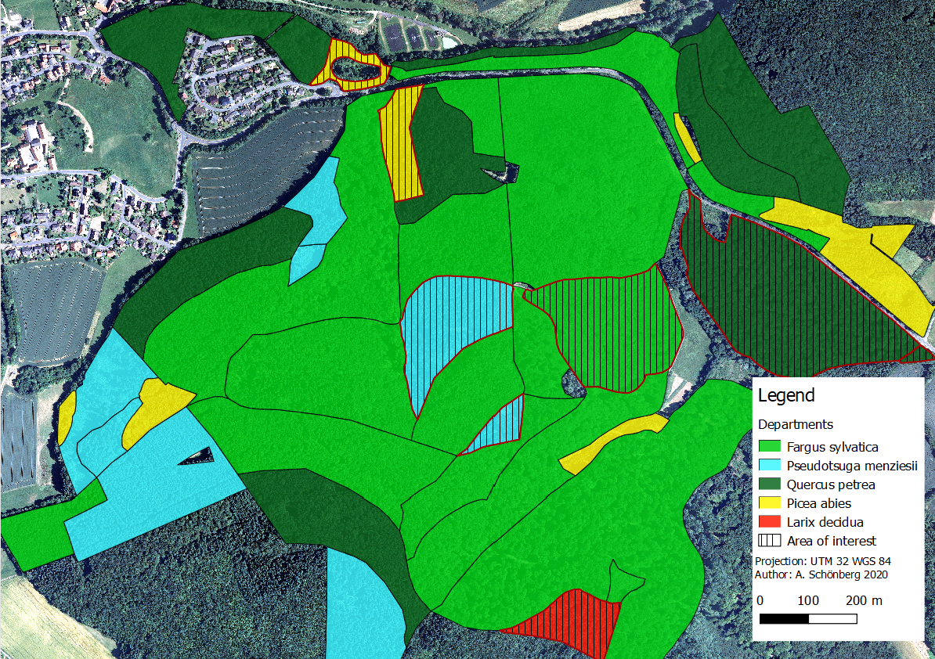

Fig. 1: Study area with forest departments and selected areas for the moss vegetation survey.

**3. Data and Methods**

To investigate our hypotheses we performed a vegetation survey with a customised nested plot design and use multiple statistical approaches to generate information about the distribution and composition of moss species in the study area (Fig. 2).

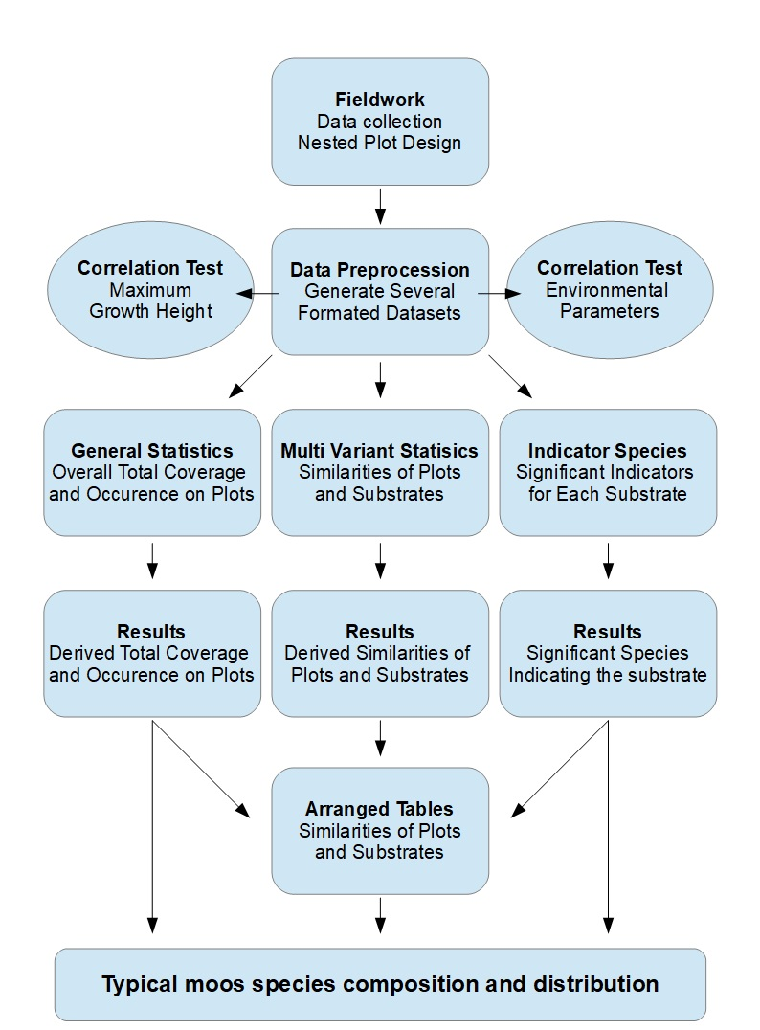

Fig. 2: Simplified schematic workflow for data analysis.

**3.1 Field Methods and sampling design**

For our study and regarding to our hypothesis we will perform a moss vegetation survey after BRAUN-BLANQUET (1928) and use a nested plot design to collect data for different substrates via multiple subplots per mainplot. For the amount of plots per forest department we searched for most representative positions (Dierschke 1994) within the departments and used a nested plot design to collect data regarding to our hypothesis. The nested plot design was chosen to improve the accuracy and reliability of moss occurrence and richness (Barnett & Stohlgren 2003, Stohlgren et al. 1995). The typical “Whittaker plot” (Shmida 1984) used multiple spatial scales (1m², 10m², 100m² subplots within a 1000m² mainplot) to collect species richness data. But this scale is too big for our approach to sample mosses so we modified it into a smaller mainplot in which we aligned all substrates (soil, deadwood, epiphyte) as subplots within. Therefore a “mainplot” was set up on a representative position within the department and a 5 meter radius was set. This area of approximately 78.5m² is comparable to a 10x10 meter squared plot which is typically used for forest vegetation plots (Dierschke 1994).

Due to the different sizes of the departments and the goal to collect representative data we calculate the amount of plot per tree species as followed. For the angiosperm species we sample on three plots in *Fagus sylvatica* departments and five plots in *Quercus petrea cf.* departments because *Fagus sylvatica* occurs there too. For the gymnosperm species we sampled on one plot for *Larix decidua* because there is only one department with poor coverage in the study area. For *Pseudotsuga menziesii* we sampled on four plots along with four plots for P*icea abies* to get equal amounts of plots for each tree species for comparison reasons. Further we sampled on a clearing to get data to compare to the forest plots.

First we estimated the coverage for the mainplot area for the tree, scrub and herb-layers as well as taking the coordinates and pictures. Then we set up the subplots for the different substrates to identify the moos species occurring on it (Fig. 3). This improves subjectivity issues of the vegetation survey as well as delivering data about the distribution of moos species within a mainplot. For the substrates we choose soil, deadwood and epiphyte because we expected to find those substrates in most plots. A planed rock subplot was discontinued because of poor rock and stone appearance on the surface of nearly all plot positions. For every subplot the species were identified and the coverage was estimated based on the Braun-Blanquet scale (Braun-Blanquet 1928) while the frequency distribution is based on the subplot type and is not in relation to the mainplot.

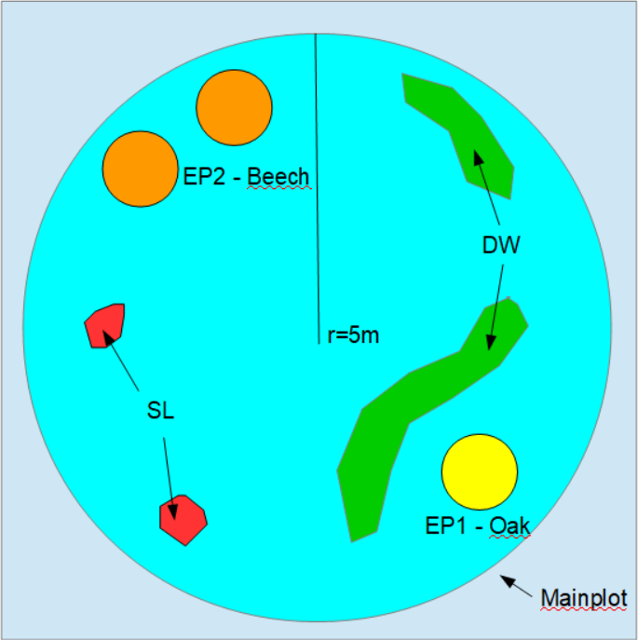

Fig. 3: Customised nested plot design: Mainplot with a 5 meter radius circle containing subplots by substrate: SL = accumulated soil subplot area; DW = accumulated deadwood subplot area; EP= Epiphyte subplot area for each tree species within the mainplot.

**3.1.1 Soil Subplots**

For the soil subplots we identified all moss species occurring on bare soil. Typically this substrate contains small elevations which are free from vegetation due to the exposition to the wind, missing sunlight and animal activity. The coverage is estimates in relation to the whole mainplot area to prevent high cover values if there is only a small area of soil related to the mainplot area. Further this allows comparing high coverage values on vegetation free areas like clearings or meadows with plots containing only small areas are free of vegetation.

**3.1.2 Deadwood subplots**

Like for soil subplots we identified all moos species occurring on deadwood, but estimated the coverage in relation to the accumulated area of deadwood in the mainplot area instead to the whole mainplot area. Here we expected deadwood occurring relatively common on the mainplots unlike the soil subplots. We focused our interest on the comparability of the species within a plot, instead of the plots between themselves.

**3.1.3 Epiphyte subplots**

For the epiphyte subplots we first identified the tree species within the mainplot. For every tree species we set up an epiphyte subplot to later compare the epiphytic moos species by tree species. Therefore we identified the moos species and estimate the coverage by the mean on all trees of the same species within the mainplot. If there are more than only a few trees we chose representative trees as a sample for the area. Further we divided the subplots into elevation levels to later test our hypothesis about the elevation dependent occurrence of moos species by tree class (Tab.1).

|  |  |
| --- | --- |
| **Level** | **Elevation** |
| 1 | ground up to 1 meter |
| 2 | 1 meter up to 2 meters |
| 3 | above 2 meters |

Tab. 1: Height levels of epiphytic subplots.

This sampling design can result in single species occurring multiple times on a mainplot with different coverage values which has to be handled in data pre-processing. If any type of substrate is missing on a mainplot we do not generate it instead of setting zeros values due to multivariate statistical approaches like ordination cannot handle zeros.

**3.2 Data preprocessing**

At First the collected data was digitalized in a single table. Additionally a second table was digitalized containing the information for the mainplot, like the coordinates and the environmental parameters of tree,- scrub,- and herb-layer coverage. For further analysis the main species table was edited to ensure that no data was missing. It is possible that the cover for a species is missing when it was found within a moos sample and not collected on the plot elsewhere. To avoid an information loss these species all get the same value for cover instead of deleting the species. Assuming that with higher coverage values the species would be collected elsewhere on the plot and to reduce a possible manipulation we assign an “r” to those species. To allow mathematical operations and perform multivariate statistical methods the Braun-Blanquet scale for the coverage is translated into numeric values. We assigned the mean value in percent from the Braun-Blanquet scale as the numeric mean value (Tab. 2).

|  |  |  |
| --- | --- | --- |
| **Braun-Blanquet scale** | **Cover in percent** | **Numeric mean conversion** |
| **r** | far less then 1 % | 0,1 |
| **+** | less then 1% | 0,5 |
| **1** | less then 5% | 2,5 |
| **2** | 5-25 % | 15 |
| **3** | 25-50 % | 37,5 |
| **4** | 50-75 % | 62,5 |
| **5** | 75-100 % | 87,5 |

Tab. 2: Braun-Blanquet scale numeric conversion to mean values.

Following our hypotheses we need two datasets, one dataset with all species occurring in the mainplots and a second dataset with the species occurring on subplots. Due to our sampling design a moos species can occur multiple times within a mainplot on different subplots and on several elevation levels on different tree species. To investigate the differences between the mainplots we need to accumulate the coverage for species occurring on multiple subplots. Therefore we used the pivot table format to calculate the mean coverage values in order to get a new dataset with the species on the mainplots independent of the substrate they occur on. To analyse the different substrates by mainplot position we further generated datasets for the three substrates (soil, deadwood and epiphyte). Further to investigate similarities of the substrate subplots we computed a dataset which includes all subplots. Additionally we compute datasets with only the occurrence of species for both the mainplots and the substrates, to reduce the importance of dominant species and to compare the plots only by the occurring species.

**3.3 Data analysis**

**3.3.1 General statistics**

First we generate a species table with all moos species occurring in the study area with information about their occurrence on the different plots. Following we calculate the species richness and total coverage for every species for the main- and subplots to get an overview of the distribution of moss species in the study area. For the total coverage we use the sum of numeric values from every subplot. This grants to compare the dominance of species within a plot but the values cannot be compared to other plots. The species richness is the amount of unique species occurring on the plot.

Further to examine the distribution of the species we identified which species occurs only on one of the different substrates to see if there are any relationships between the substrates. To examine the distribution of species on the substrates we identified those species only occurring on a single substrate to see if we find typical species for the substrates. If those typical species are missing because they occur on more than one substrate we generated two lists with terrestrial species by combining the species occurring on deadwood and soil and test which species occur on epiphyte. The same procedure is performed for epiphytic species by combining epiphyte and deadwood species and check which do not occur on soil.

**3.3.2 Multivariate statistics**

To investigate our hypothesis that the moss compositions depends on the forest department or on the substrates we need to analyze similarities between the departments and or substrates. Our processed data consists of multivariate information for the plots (species and their respective coverage) which is mathematically described as a multi dimensional hyperspace. To handle this n-dimensional hyperspace we use the multivariate statistical approaches of ordination and cluster analysis as described in Leyer & Wesche (2007) and the “Vegan” Package for R (Oksanen et al. 2018).

An Ordination reduces the dimension down to two with a loss of information but allows to see the relationship of the tested objects (in our case the plots). Objects in close neighbourhood are more similar to each other than objects in greater distance. The cluster analysis is a method to show the relationship of tested data, where similar plots are arranged in close distance to each other. We use a combination of an ordination and cluster analysis to visualize the similarities of our datasets. From the plenty algorithms available we choose the detrended correspondence analysis (DCA), non metric multidimensional scaling (NMDS) ordinations and the hierarchic Clustering (HC) as well as the k-means clustering (KM) (Hill & Gauch 1980, Leyer & Wesche 2007, Minchin 1987). For the cluster methods a desired amount of clusters can be chosen.

To compare the impact of the coverage values we will use both datasets with coverage and with only the occurrence of species. Further it is possible that there occur dominate species which occurs on most plots and cannot be used to compare the plots. These species could affect the results for the multivariate statistical methods, because they would indicate a similarity between plots but do not differ by department or substrate. Therefore we test our datasets for significant dominate species and compute new datasets (cleaned) without these species.We will perform this workflow on both datasets for the mainplots and the subplots. For the clustering we need to assign the amount of desired clusters. For the mainplot analysis we choose five clusters. Regarding to our hypothesis we expect one cluster for each of the five main tree species (Beech, Oak, Spruce, Douglas fir, Larch).

**3.3.3 Indicator species test**

To describe the typical moos species compositions we analyse our datasets for significant indicator species. We use the Dufrene-Legendre Indicator Species Analysis from the “labdsv” package (Roberts 2016). Concerning our hypothesis that the moos compositions can be separated to the substrates, we performed a test on a pre-arranged dataset with one cluster for each subplot. Hereby we use both datasets with coverage and only occurrence and either with or without dominant species (cleaned dataset).

**3.3.4 Arranged species tables**

The results from the multivariate statistics along with the general statistics and indicator species test results serves to get an overview on the collected data. To find relationships which were not detected, we use the combined results to manually arrange the species table. For these arranged species tables we converted the numerical mean values back to the Braun Blanquet scale for an easier interpretation. The species table is manually arranged by moving the rows and columns until most cells with content are arranged in direct neighbourhood. According to our hypothesis about similarities of the mainplots we arrange the table with the mainplot data. Further we arrange the table with all substrate plots to investigate similarities within the different substrates independent of the plots position.

**3.3.5 Correlation test environmental parameters**

To test if there are any correlations between the collected environmental parameters (tree-, shrub-, and herb-layer coverage) and the richness and total coverage of the plots, we used a Spearman correlation test. We tested both the total coverage and species richness against the coverage of tree, scrub and herb layers as well against the tree species and the tree class (angiosperm and gymnosperm).

**3.3.6 Correlation tests maximum growth height**

Finally to test our hypothesis that the elevation distribution of epiphytic moss species depends on the tree species, we analyze the correlation between the maximum height level where the moss species occur and the tree class (angiosperm/gymnosperm) it was collected on. Therefore we used our collected data for the epiphyte subplots with information about the maximum height level to test if any moos species occur on all tree species. Further we assign a column for angiosperm and gymnosperm to generate the tree-class parameter. Then we used the correlation test with the Pearson method to see if there is a correlation between the tree-class and the maximum height level of epiphytes.

**4. Results**

**4.1 Fieldwork**

In the vegetation survey we collected data in the selected departments on 18 mainplots in total (Fig. 4). The *Fagus sylvatica, Quercus petrea* and *Pseudotsuga menziesii* departments show the typical homogenous forest structure we expected and can be clearly distinguished. The *Picea abies* departments are in comparison relatively small and hard to distinguish and containing only small amounts of trees. Especially on plot 28 the forest structure was not comparable to the other departments. On plot 26 we found a small population of Gymnosperm, (estimated *Picea abies / Pseudotsuga menziesii)* but the department is marked as *Fagus sylvatica*. We use this plot for comparison reasons to test for similarities independent of the department. Plot 25 represents a clearing containing single individuals of *Carpinus betulus, Larix decidua* and *Sorbus aucuparia*. The *Larix decidua* department(Plot 21)does not have a typical forest structure and looks more like a clearing (Plot 25) with only some single trees on a meadow.

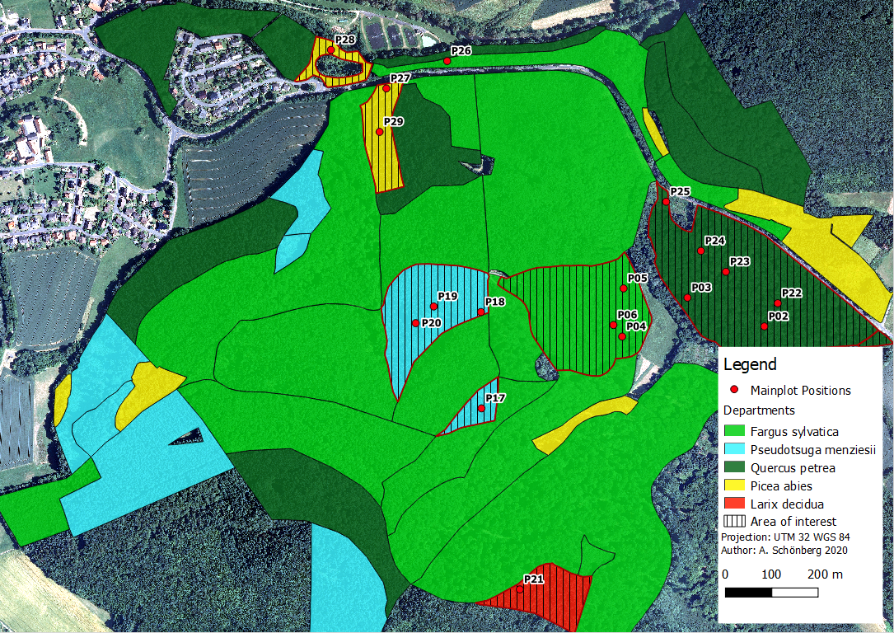

Fig. 4: Study area with forest departments and mainplot position.

**4.2 Occurence and Coverage**

In total we found 32 different moos species in the study area. One species could not be identified and is marked as “x”. Most common species overall is *Hypnum cupressiforme* occurring on every mainplot (18/18) with the by far highest dominance in total coverage (Tab.3). Further common species are: *Brachythecium rutabulum* (15/18), *Dicranum scoparium* (12/18), *Politrichum formosum* (11/18) and *Orthotrichum affine* (11/18). For the soil subplots *Politrichum formosum* (10/14), *Brachythecium rutabulum* (8/14) and *Atrichum undulatum* (8/14) are the most common species and with their respective total coverage, they represent the typical composition on soil in the study area. While *Hypnum cupressiforme* occurred very rare on soil compared to the other substrates (3/14) it is the most common species on deadwood (17/18) and epiphyte (30/30) subplots. Typical compositions on deadwood are *Hypnum cupressiforme* (17/18), *Brachythecium rutabulum* (12/18) *and Dicranum scoparium* (9/18). The epiphyte subplots show a high amount of species occurring only on very few plots compared to the other substrates. Again *Hypnum cupressiforme* (30/30) and *Brachythecium rutabulum* (14/30) represent the typical species along with *Orthotrichum affine* (11/30).

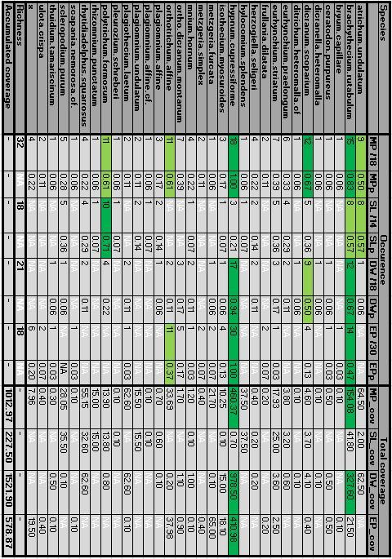Tab. 3: Species table occurrence and total coverage: EP = epiphyte subplot; DW = deadwood subplot; SL = soil subplot (“x” = unidentified species).

Some species only occur on a single substrate, others on two or on all three. Species that only occurred on soil subplots are *Hylocomium splendens, Plagiomnium affine cf , Plagiomnium undulatum*, *Pleurozium schreberi* and *Rhizomnium punctatum*. On deadwood subplots *Dicranella heteromalla* and *Ditrichum heteromalla cf* and on epiphyte subplots *Bryum capillare, Frullania dilatata, Metzgeria simplex, Scapania nemorosa cf, Ulota crispa* and “x”. Some typical epiphytes like *Orthotricum affine* and typical terrestrial species like *Polytrichum formosum* are missing in this list because they occur on deadwood too. With the deadwood substrate combined to both the soil and the epiphyte we get two lists that are more likely representing the typical compositions seen in the field.

For terrestrial species (not occurring as epiphytes) there are: *Atrichum undulatum, Eurhynchium praelongum, Herzogiella seligeri, Hylocomium splendens, Plagiomnium affine, Plagiomnium affine cf., Plagiomnium undulatum, Pleurozium schreberi, Polytrichum formosum, Rhizomnium punctatum, Rhytidiadelphus squarrosus and Scleropodium purum.*

And for epiphytes (not occurring on soil*): Bryum capillare, Ceratodon purpureus, Frullania dilatata, Metzgeria furcata, Metzgeria simplex, Orthodicranum montanum, Orthotrichum affine, Plagiothecium laetum, Scapania nemorosa cf., Thuidium tamariscinum, Ulota crispa and "x".*

**4.3 Results - Multivariate statistics for mainplots**

The dataset for the mainplots with coverage is highly dominated by *Hypnum cupressiforme* and *Brachythecium rutabulum (*Fig. 5*)* as well *Hypnum cupressiforme* occurs on all plots and *Brachythecium rutabulum* on 15/18 plots. Therefore we use cleaned datasets without both species additionally to the full datasets.

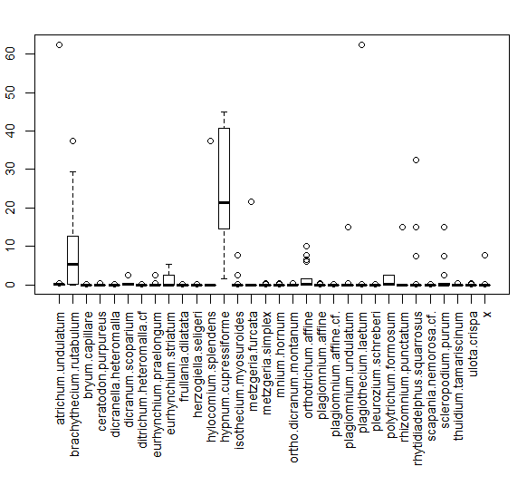

Fig. 5: Mainplot coverage (“x” = unidentified species).

The multivariate statistical method shows no significant similarities of the forest departments (Fig. 6) independent on the used dataset. In general the plots are arranged in close distance to each other, independent of the tree type. For example the *Pseudotsuga menziesii* (PM) plots can be found in close distance to each other but they are not separated clearly from the other plots. Further the *Quercus petrea* (QP) plots are arranged in close distance to each other but are mixed together with some *Fagus sylvatica* (FS) plots. The best result is generated by the dataset with only the occurring species including the dominant ones. Here the plots with angiosperm tree species occurs in close distance to each other in the blue cluster and further the gymnosperm tree species plots are arranged in two separated clusters (black and turquoise). But even with this dataset it is not possible to clearly separate the moos species compositions by the tree typ.

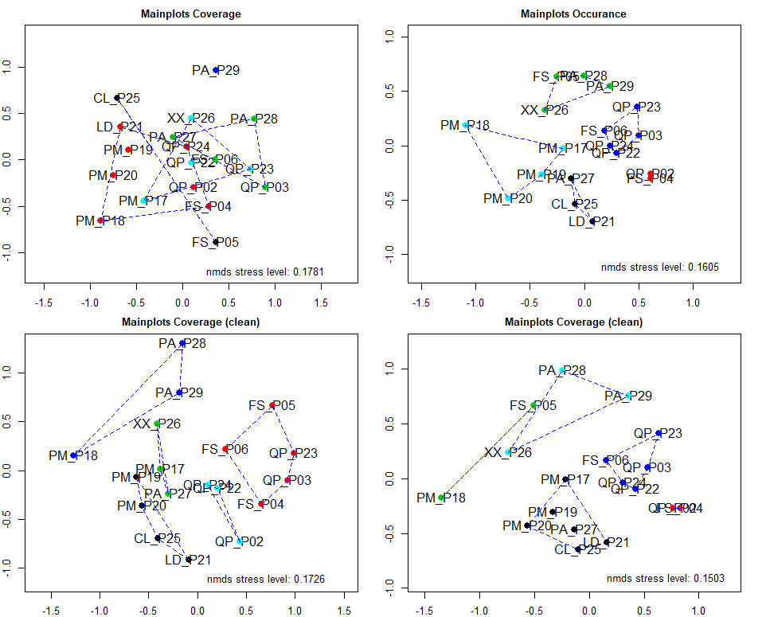

Fig. 6: Results mainplot ordination clustering: PM =*Pseudotsuga menziesii;* QP = *Quercus petrea*; FS = *Fagus sylvatica*; PA = *Picea abies;* LA *= Larix decidua;* CL *=* clearing; XX = unknown gymnosperm tree species (estimated PM or PA); Pxx = plot number.

**4.4 results - Multivariate statistics for Subplots**

The dataset with all subplots (with coverage) is highly dominated by H*ypnum cupressiforme* *(*Fig. 7) and occurs on 50/62 subplots. Additionally to the datasets with all species with coverage and with only occurrence we therefore used cleaned datasets without *Hypnum cupressiforme.*

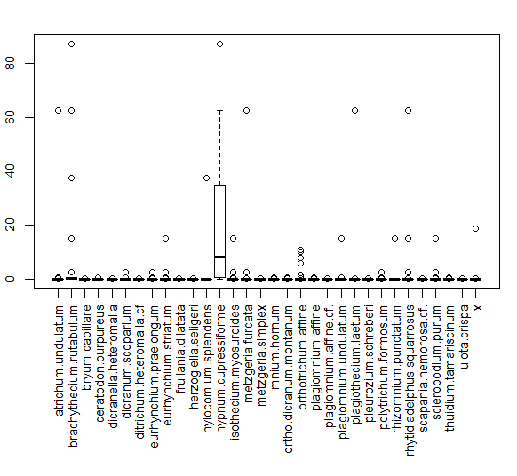

Fig. 7: Subplots coverage (“x” = unidentified species).

The result for the ordination of the subplot datasets with all species show a separation of the soil plots (SL) from the epiphytic (EP) and deadwood (DW) plots which are in very close distance to each other (Fig. 8). The deadwood plots are located between the soil and epiphytic plots. Combined with the cluster analysis most plots of a single substrate are arrange together in a cluster. Especially with only single occurrences of species we can see a possible relationship within the subplots. There are clearly separated soil and epiphytical plots with deadwood plots between them. On the other hand with the cleaned datasets some epiphytic plots are more unequal to all other plots and therefore the rest of the plots are arranged in close distance. But even here we can see that some soil and epiphytic subplots are separated while deadwood plots are mixed with both other substrates.

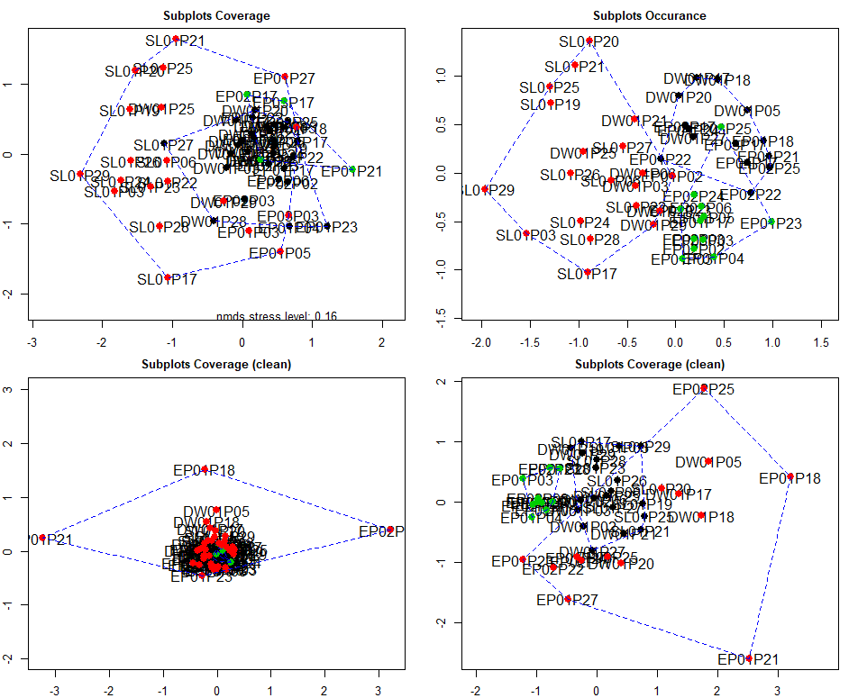

Fig. 8: Results subplot ordination clustering: EP = epiphyte subplot; DW = deadwood subplot; SL = soil subplot; Pxx = plot number.

**4.5 Results - indicator species**

We could not find any significant indicator species for the mainplots. The results of the prearranged dataset show significant indicator species for all three substrates (Tab. 4). This underlay’s our estimation that the moos species compositions depend on their respective substrates.

|  |  |  |  |
| --- | --- | --- | --- |
| **Species** | **Cluster** | **Indicator value** | **Value probability** |
| **SUa cover** | | | |
| Hypnum cupressiforme | 1 | 0.7575 | 0.001 |
| Brachythecium rutabulum | 1 | 0.5551 | 0.008 |
| Orthotrichum affine | 2 | 0.3406 | 0.012 |
| Polytrichum formosum | 3 | 0.6835 | 0.001 |
| Scleropodium purum | 3 | 0.3564 | 0.001 |
| Eurhynchium striatum | 3 | 0.3132 | 0.006 |
| Eurhynchium praelongum | 3 | 0.2494 | 0.013 |
| **SUa cover cleaned** | | | |
| Brachythecium rutabulum | 1 | 0.5495 | 0.010 |
| Orthotrichum affine | 2 | 0.4551 | 0.002 |
| x | 2 | 0.2500 | 0.032 |
| Polytrichum formosum | 3 | 0.6835 | 0.001 |
| Scleropodium purum | 3 | 0.3564 | 0.002 |
| Eurhynchium striatum | 3 | 0.3093 | 0.012 |
| Eurhynchium praelongum | 3 | 0.2494 | 0.028 |
| **SUa only occure** | | | |
| Hypnum cupressiforme | 2 | 0.4632 | 0.001 |
| Orthotrichum affine | 2 | 0.2598 | 0.033 |
| X | 2 | 0.1875 | 0.044 |
| Polytrichum formosum | 3 | 0.5448 | 0.001 |
| Atrichum undulatum | 3 | 0.5208 | 0.001 |
| Scleropodium purum | 3 | 0.3091 | 0.001 |
| Eurhynchium striatum | 3 | 0.2298 | 0.026 |
| Eurhynchium praelongum | 3 | 0.2057 | 0.020 |
| Rhytidiadelphus squarrosus | 3 | 0.2057 | 0.020 |
| **SUa only occure cleaned** | | | |
| Orthotrichum affine | 2 | 0.3689 | 0.002 |
| X | 2 | 0.2500 | 0.008 |
| Polytrichum formosum | 3 | 0.5448 | 0.001 |
| Atrichum undulatum | 3 | 0.5208 | 0.001 |
| Scleropodium purum | 3 | 0.3091 | 0.004 |
| Eurhynchium praelongum | 3 | 0.2057 | 0.040 |
| Rhytidiadelphus squarrosus | 3 | 0.2057 | 0.043 |

Tab. 4: Results indicator species test for presorted species table: cluster number is = 1 DW 2 EP 3 SL; SUa = Clusters prearranged by substrate (“x” = unidentified species).

**4.6 Results - arranged species tables**

The manually arranged species tables for the mainplots (Tab. 5) show equal results as the cluster analysis (Fig. 6). While some departments of the same tree type share the same species these species occur on other plots too. For example *Eurynthchium striatum* can be found on all PM plots but occur on two other plots. In addition there are no specific species combinations which only occur within the same tree typ. With this result we have to decline our hypothesis that there are typical moos compositions which depend on the forest type. But we can see that there are slightly similarities between the departments containing gymnosperm tree species as well as between departments with angiosperm tree species.

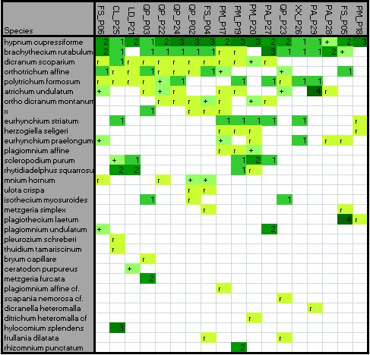

Tab. 5: Results MVS hand sorted subplots: : PM =*Pseudotsuga menziesii;* QP = *Quercus petrea*; FS = *Fagus sylvatica*; PA = *Picea abies;* LA *= Larix decidua;* CL *=* clearing; XX = unknown gymnosperm tree species (estimated PM or PA); Pxx = plot number (“x” = unidentified species).

The relationship between the tree substrates can be seen more clearly in the manually arranged species table (Tab. 6). There are significant moos species compositions on the soil and epiphytic subplots which do not share any species with each other while both share species with deadwood. On the other hand the deadwood subplots only contains two unique species occurring which only occurs on deadwood: *Ditrichum heteromalla cf.* and *Dicranella heteromalla.* Except *Hypnum cupressiforme and Brchythecium* onlythree species occurs on all three substrates. These are *Mnium hornum, Dicranum scoparium and Eurynthium striatum.* But even with *Hypnum cupressifirme* and *Brachythecium* which occurs on all substrates we can see significant differences*: On deadwood the cover of both species is higher than on epiphytic plots. Further both species occurred much lesser on soil and with only low coverage.*

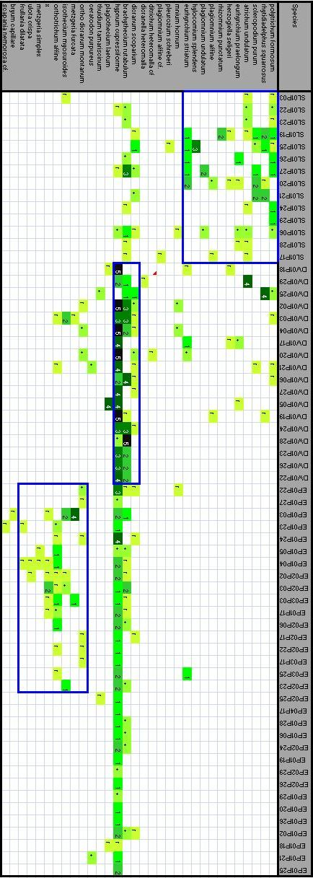

Tab. 6: Manually arranged species table: EP = epiphyte subplot; DW = deadwood subplot; SL = soil subplot; Pxx = plot number (“x” = unidentified species).

**4.7 correlation results of maximum growth height**

In total we found nine tree species on our mainplots (with their respective amount of subplots): *Fagus sylvatica* (8), *Quercus petrea cf* (6), *Picea abies* (4), *Carpinus betulus* (2), *Betula pendula* (2), *Larix decidua* (2), *Pseudotsuga menziesii* (4), *Sorbus aucuparia* (1) and *Acer spec* (1). We hypothesize that there is a correlation between the tree type and the maximum height of epiphytes. The correlation between the tree class and the maximal height of epiphytes delivers a correlation value of -0.6111822 with a p-value of 0.0004283. Except on one *Larix decidua,* gymnosperms only have epiphytes up to one meter while on angiosperms moos species typically reaches up to two meters. With this result we can conclude our hypothesis that angiosperm have epiphytes in higher elevations.

**4.8 correlation results environmental parameters**

We could not find any significant correlations (excluded scrub layer coverage vs. richness) between the species richness or total coverage and the tested environmental parameters (Tab. 7).

|  |  |  |  |
| --- | --- | --- | --- |
| **Variable 1** | **Variable 2** | **Cor. value** | **P-value** |
| Richness | Tree layer coverage | 0.0509392 | 0.8409 |
| Richness | Scrub layer coverage | -0.5039678 | 0.03297 |
| Richness | Herb layer coverage | -0.09983415 | 0.6935 |
| Richness | Tree species | -0.396783 | 0.103 |
| Richness | Tree class | -0.3476427 | 0.1575 |
| Total coverage | Tree layer coverage | -0.1783518 | 0.4789 |
| Total coverage | Scrub layer coverage | 0.03294554 | 0.8967 |
| Total coverage | Herb layer coverage | 0.08304375 | 0.7432 |
| Total coverage | Tree species | 0.1318336 | 0.6021 |
| Total coverage | Tree class | -0.2634893 | 0.2908 |

Tab. 7: Correlation of environmental parameters with coverage and species richness.

**5. Discussion**

In general moos species can be more difficult to identify than other plants (De Queiroz 2007). Species which we could not identify in the field were collected and identified later. It is possible that some species where not found in the field but later found within a sample. In this case we could not estimate the coverage afterwards. Some moss species can be difficult to distinguish. For example the *Metzgeria species* or *Orthodicranum montanum* and *affine* were difficult to keep apart.Therefore we avoided to artificially generate more different species due to unsure identification results by choosing the same species for similar moos samples. For example if we estimated most *Orthodicranum* species to be *montanum* we avoided to identify a single sample as *affine* if we are not very sure of its difference. It is possible that we found more or less species due to the identification.

With our results we can estimate that the moos composition depends on the respective substrate and not on the dominant tree species. Thus we can assume that there is a moss distribution gradient within the substrates. There are moss species that are unique either on epiphytical or on soil substrates while on deadwood substrates we found species from both other substrates. Therefore we assume a succession process from epiphytic- over deadwood- to soil-substrates. We assume that epiphytical species can be found on deadwood because branches or bark with epiphytical mosses on it falls down on the ground (Fig. 9). In this condition the fallen down branches/bark is assigned to deadwood and not epiphytic substrate. Therefore epiphytic species remain on deadwood while the process of decay proceeds. With further decay of the branch/bark typical deadwood species settle down. At the end of the decay process the deadwood is converted to soil and typical soil species can settle down while epiphytic species were replaced.

Furthermore we could not find any correlations between our collected environment parameters with the coverage of moos species and or the amount of different moos species. We expect that there are different environmental parameters especially the micro-climate conditions which affect the biodiversity and total coverage of moos species. We further assume that the biodiversity of moos species depend much more on the zonal-climatic conditions than on the forest type. In our vegetation survey method we assigned species occurring on the base of a tree to the epiphytic substrate but especially on tree roots some soil can be accumulated. Therefore we found typical terrestrial species like *Eurynthium striatum* on tree bases and assigned them to epiphytical substrates. This could result in some difficulties to find similarities in the epiphytical plots for the multivariate statistical methods***.***

We conclude that the height where epiphytical moss species occur on trees depends on the tree class (angiosperm/gymnosperm). We assume that this is affected by the different humidity of the barks. While gymnosperm tree species have constant branches which protect from raining, the barks of angiosperm tree species are more humid due to rain from the sides. Further the different water flow on the stem of angiosperms and gymnosperms tree species might affect the humidity.

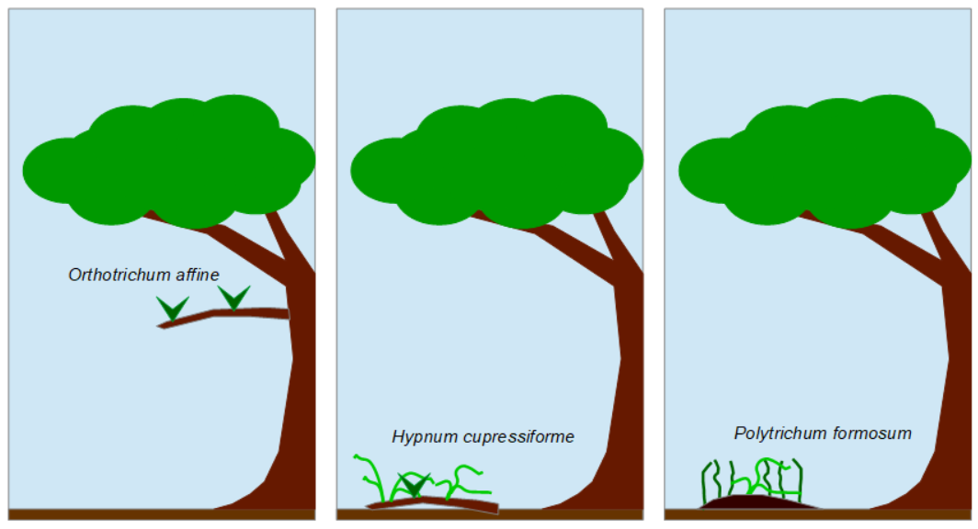

Fig. 9: Schematic assumption of Indicator species distribution circle on a fallen down branch: Left: epiphytic *Orthotrichum affine* on a branch. Mid: *Hypnum cupressiforme* settles down on the deadwood with remaining *Orthotrichum affine*. Right: The branch is fully decayed to soil and *Polytrichum formosum* settles down with small remaining amounts of *Hypnum cupressiforme* and no remaining *Orthotrichum affine*.

We estimated the coverage values for the substrates in relation to their respective area of the substrate except for soil. Here we used the absolute area of the main plot. Due to this sampling design, difficulties could occur in comparing the soil subplots with the other substrates. While this helped to compare plots with high amount of soil (eg. clearings) with the small soil spots on forest plots, this leads to small coverage values (r and +) for most soil species. Therefore we expect that a clearing can be separated from forest plots very clearly but the soil subplots on forest plots would not differ much in the coverage of species. This could lead to problems in the comparability between the substrates in the multivariate statistical approach due to the small range of soil coverage. In our study area we have only one small department with *Larix decidua* and further in this department only a few *Larix decidua* occur. Compared to the other main tree species departments we could collect less data for *Larix decidua* which may affect the significance of our results compared to the other plots.

**6. Conclusion**

Regarding to our results we can conclude that moss species compositions in richness and appearance are not dependent on the forest department but on the substrate. We could identify common moss patterns and indicator species to describe typical moss compositions expected for each substrate in the study area. As epiphyte species *Hypnum cupressiforme* and *Brachythecium rutabulum can be expected* along with *Orthotrichum affine* as the typical indicator species. Further their maximum growth height depends on whether they are growing on angiosperm or gymnosperm tree species. The deadwood substrate is highly dominated by *Hypnum cupressiforme* along with *Brachythecium rutabulum as well as Dicranum scoparium with fewer occurrence and coverage.* The soil substrate can be differentiated into open meadows and small shadowed forest spots. On forest spots *Polytrichum formosum, Atrichum undulatum* and *Brachythecium rutabulum* forms the typical composition while *Rhytidiadelphus squarrosus* and *Scleropodium purum* can be expected as typical soil species on meadows.

**References:**

**Anderson, L. E. (1963):** **Modern** *Species Concepts: Mosses.* In: The Bryologist. Volume: 66, Pages: 107-119

**Barnett, D. T. & T.J. Stohlgren (2003):** *A Nested-Intensity Design For Surveying Plant Diversity.* In: Biodiversity And Conservation. Volume: **12,** Pages: 255-278

**Bodenviewer (2020):** *Geologische Karte Deutschlands*<http://bodenviewer.hessen.de/mapapps/resources/apps/bodenviewer/index.html?lang=de> (Access: 25.01.2020)

**Braun-Blanquet, J. (1928):** *Pflanzensoziologie. Grundzüge der Vegetationskunde.*Montpellier

**Cove, D.J., Knight, C.D. & T. Lamparter (1997):** *Mosses As Model Systems.* In: Trends Plant Science. Volume: 2, Pages: 99-105

**Crosby, M.R., Magill, R.E., Allen, B. & S. He (1999):** *A Checklist Of The Mosses.* In: Prospectus. Missouri Botanical Garden, St. Louis, Page: 1

**De Queiroz, K. (2007):** *Species Concepts And Species Delimitation*. In: Systematic Biology. Volume: 56, Pages: 879-886

**Dierschke, H. (1994**): *Pflanzensoziologie: Grundlagen und Methoden.* Ulmer, Stuttgart.

**Drehwald, U. (2010):** *Nachsuche Verschollener Moose Für Die Hessische Rote Liste Moose*. Göttingen

**Drehwald, U. (2013):** *Rote Liste Der Moose Hessens.* In: Hess. Ministerium Für Umwelt, Energie, Landwirtschaft Und Verbraucherschutz (Hmuelv), Pages: 78

**During H.J. (1979):** *Life Strategies Of Bryophytes: A Preliminary Review.* In: Lindbergia. Volume: 5, Page: 2-18

**Fenton, N.J. & K.A. Frego (2005):** *Bryophyte Conservation Under Remnant Canopy In Managed Forests*. In: Biological Conservation. Volume: 122, Pages: 417-430

**Frahm J.P. (2004):** *Recent Developments Of Commercial Products From Bryophytes.* In: The Bryologist. Volume: 107, Pages: 277-283

**Frahm. J.P. &W. Frey (1992):** *Moosflora.* Page: 8

**Frego K.A. (2007):** Bryophytes *As Potential Indicators Of Forest Integrity.* In: Forest Ecology Management. Volume: 242, Pages: 65-75

**Frey, W. & H. Kürschner (2011):** *Asexual Reproduction, Habitat Colonization and Habitat Maintenance In Bryophytes - A Review.* In: Flora. Volume: 206, Pages: 173-184

**Gerson, U. (1969):** *Moss-Arthropod Associations.* In: The Bryologist. Volume: 72, Pages: 495-500

**Gignac, L. D. (2001):** *Bryophytes As Indicators Of Climate Change.* In: The Bryologist. Volume: 104, Pages: 410-420

**Giordano, P., Adamo, S., Sorbo, S. & S. Vingiani (2005):** *Atmospheric Trace Metal Pollution In The Naples Urban Area Based On Results From Moss And Lichen Bags*. In: Environmental Pollution. Volume: 136, Pages: 431-442

**Harmens, H., Norris, D. A., Steinnes, E., Kubin, E., Piispanen, J., Alber, R., Aleksiayenak, Y., Blum, O., Coskun, M., Dam, M., De Temmerman, L., Fernandez, J. A., Frolova, M., Frontasyeva, ´ M., Gonzalez-Miqueo, L., Grodzi ´ Nska, K., Jeran, Z., Korzekwa, ´ S., Krmar, M., Kvietkus, K., Leblond, S., Liiv, S., Magnusson, ´ S. H., Mankovsk ˇ A, B., Pesch, R., R ´ Uhling, ¨ A., Santamaria, J. M., ˚ Schroder, W., Spiric, Z., Suchara, I., Th ¨ Oni, L., Urumov, V., Yu- ¨ Rukova, L., & H. G. Zechmeister (2010):** *Mosses As Biomonitors Of Atmospheric*

*Heavy Metal Deposition: Spatial Patterns And Temporal Trends In Europe.* In: Environmental Pollution. Volume: 158, Pages: 3144-3156

**Hessisches Landesamt für Umwelt und Geologie (2007):** *Geologische Übersichtskarte von Hessen*. Wiesbaden

**Hill, M.O. & H.G. Gauch (1980):** *Detrended Correspondence analysis: an improved ordination technique*. In: Vegetation, Volume:42, Pages: 47-58

**Ilić, M., Igić, R., Ćuk, M. & D. Vukov (2018):** *Field Sampling Methods For Investigating Forest-Floor Bryophytes: Microcoenose Vs. Random Sampling.* In: Archives Of Biological Sciences. Volume: 70(3), Pages: 589-598

**Leyer, L. & K. Wesche (2007):** Multivariate *Statistik In Der Ökologie. Einfache Einführung In Die Vielfältigen Methoden Der Multivariaten Analyse Ökologischer Daten.* Springer, Heidelberg

**Meinunger, L. & W. Schröder (2007):** *Verbreitungsatlas der Moose Deutschlands*. Hrsg. O. Dürhammer für die Regensb. Bot. Ges., 3 Bd., Regensburg

**Mezaka, A., Brumelis, G. & A. Piterans (2012):** *Tree And Stand-Scale Factors Affecting Richness And Composition Of Epiphytic Bryophytes And Lichens In Deciduous Woodland Key Habitats.* In: Biodiversity Conservation. Volume: 21, Pages: 3221-3241

**Minchin, P. R. (1987):** An *evaluation of the relative robustness of techniques for ecological ordination*. In: Vegetatio, Volume: 69, Pages: 89-107

**Mishler, B. D. (1985):** *The Morphological, Developmental, And Phylogenetic Basis Of Species Concepts In Bryophytes.* In: The Bryologist. Volume: 88, Pages: 207-214

**Nentwig, W., Bacher, S., Brandl, R., & M. Lay (2009):** *Ökologie Kompakt.* Spektrum Akademischer Verlag Gmbh. Heidelberg

**Ogwu, M. C. (2019):** *Ecological and Economic Significance of Bryophytes.* URL: https://orcid.org/0000-0001-6054-1667 Seoul National University (Access: 17.01.2020)

**Oksanen, J., Guillaume Blanchet, F., Friendly, M., Kindt, R., Legendre, P., McGlinn, D., Minchin, P. R., O'Hara, R. B., Simpson, G. L., Solymos, P., Stevens, M.H.H., Szoecs, E. & Helene Wagner (2019)**: *Community Ecology Package*. URL: <https://github.com/vegandevs/vegan> (Access: 29.01.2020)

**Opentopomap (2020):** <https://opentopomap.org/#map=15/50.83684/8.67922> (Access: 29.01.2020)

**Peck, J.E. (2006):** *Towards Sustainable Commercial Moss Harvest In The Pacific North-West Of North America.* In: Biological Conservation. Volume: 128, Pages: 289–297

**Roberts, D. W. (2016):** *Labdsv-package.* *Dufrene-Legendre Indicator Species Analysis. Ordination and Multivariate Analysis for Ecology. URL:* <https://github.com/cran/labdsv> (Access.25.03.2020)

**Shmida, A. (1984):** *Whittaker’s plant diversity sampling method*. Israel journal of Botany. Volume: 33, Pages: 41-46

**Stohlgren, T.J., Falkner, M. B. & L. D. Schell (1995):** *A Modified-Whittaker Nested Vegetation Sampling Method.* In: Plant Ecology. Volume 117, Number 2 / April, 1995. Pages: 113-121

**Turetsky, M. R. Et Al. (2012):** *The Resilience And Functional Role Of Moss In Boreal And Arctic Ecosystems.* In: New Phytology. Volume:196, Pages: 49-67

**Zechmeister, H.G., Grodzinska, K. & G. Szarek Lukaszewska (2003):** *Bryophytes*. In: Markert, Bioindicators And Bio-Monitors. Elsevier Science Ltd., Amsterdam, Pages: 329-375.